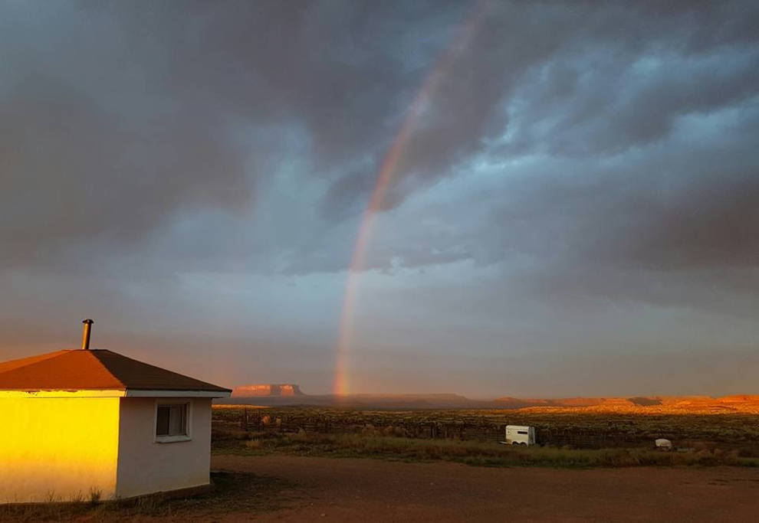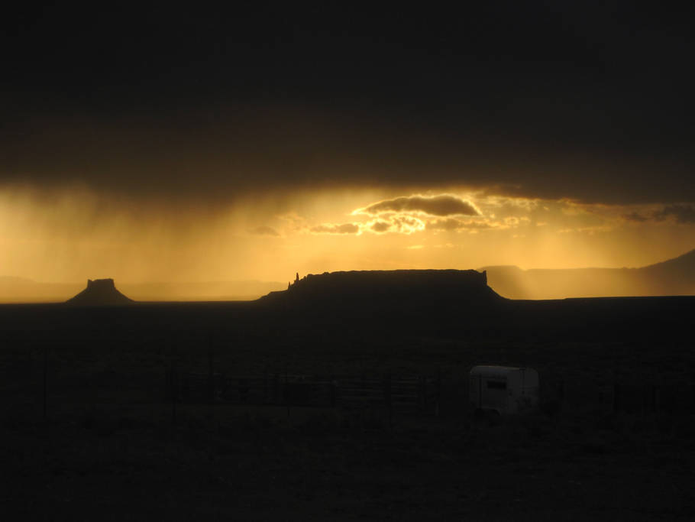
Songwriting Retreat on Navajo Nation
What: Songwriting and Yoga Retreat hosted by Kristina Jacobsen with special guests Meredith Wilder (songwriting, singing), Chucki Begay (songwriter- in-residence) and Erin Hansbrough (yoga)
When: May 25, 2018 (check in between 15.00-17.00 on May 25; check out between 11.00-1.00 June 1); optional opportunity to perform in a showcase at the Albuquerque Folk Fest on Saturday, June 2nd.
Where: Many Farms, Arizona (Navajo Nation)
Why: To explore your songwriting/artistry in a place accessible to few outsiders; to get to know a beautiful place known as the Navajo Nation; to push yourself beyond your comfort zone as singer, songwriter, storyteller and traveler.
How: Fly to Albuquerque, New Mexico (recommended: Norwegian Airlines from Copenhagen, Stockholm, Berlin or Rome to Los Angeles or New York, then New York /L.A. to Albuquerque):
transportation provided from Albuquerque to Many Farms and back, departing 11.30 on 5/25 and arriving back in Albuquerque by 16.30 on 6/01 (If you are planning to perform in the designated showcase at the FolkFest on June 2nd you’ll want to plan to fly out on Sunday, June 3rd). It is a 4 1⁄2 drive from Many Farms, Arizona, to Albuquerque, New Mexico. Alternately, you can also fly into Sky Harbor Airport in Phoenix (7 hour drive to Many Farms) or the smaller (and more expensive) airports in Flagstaff, AZ or Durango, CO (3 1⁄2 hour drive). Please note we are only able to provide group transportation to/from the airport in Albuquerque, New Mexico.
NB: This retreat is for adventurous spirits, only. You will be “roughing it” and there is limited access to running water (limited showers and WiFi are available on-site).1 In return, you will experience one of the most quiet and peaceful places you have perhaps ever been, where wild horses run past your campsite each morning, the nearest house is four miles away, and where you can see for over 100 miles.
Logistics: The retreat is on the Colorado Plateau, meaning that you will be at an elevation on the mesa of about 6,000 feet above sea level in a “high desert” environment (warm during the day; cooler at night: average high of 88 °F during the day, average of 53 °F at night). For folks traveling from sea level or close to sea level, this means that you will want to drink lots of extra water while on the retreat, and that you may be more tired than usual for the first 1-2 days. For this reason, some people like to fly in to Albuquerque 1-2 days early, to acclimate to the elevation and environment before plunging into the retreat and traveling to the reservation.
What to bring: tent, second-favorite instrument (if you play one) and yoga mat (for folks traveling in the U.S.); for folks traveling internationally, we will provide tents and yoga mats to loan you (please let us know if you plan to bring your own, instead). Benadryl or another basic anti-histamine in a new environment is also highly recommended. Sun protection (sunblock, hats, protective clothing) are essential, as are any allergy medications you anticipate needing on a daily or emergency basis.
Medical Care: In case of adverse medical events, there is a small private day clinic located twenty minutes north of the retreat center (Chilchinbito Clinic with Canyonlands Healthcare) with an excellent Physician’s Assistant, Cheryl Fowler; for emergencies, there is an urgent care facility at Chinle Indian Health Services Hospital (sees both Native and non-Native patients on an emergency basis) located thirty minutes south of the retreat (our retreat host/landowner, Arlondo Bia, is an employee at the hospital and knows most of the staff on duty, there). We will also have a first aid kit and basic medical supplies on hand.
More Information: contact the organizer, Dr. Kristina Jacobsen, at: kristinajacobsen@gmail.com
1 The ranch is equipped to offer 2 showers per person/per week. For those needing/wanting daily showers and having their own transportation, clean public showers are available thirty minutes away in the town of Chinle at the Aquatic Center for $1.00.

